Muhammad Laraib Akhtar
Parallel Distributed Computing
Assignment 1

Part 0

Processor Details:
Vendor: GenuineIntel
Model: Intel(R) Core(TM) i5-8350U CPU @ 1.70GHz
Architecture: x86_64
CPU Family: 6
Model Number: 142
Number of Cores: 4
Number of Threads per Core: 2
CPU Frequency:
Minimum: 400.0000 MHz
Maximum: 3600.0000 MHz
Cache Sizes:
L1d: 128 KiB (4 instances)
L1i: 128 KiB (4 instances)
L2: 1 MiB (4 instances)
L3: 6 MiB (1 instance)
Address Sizes:
Physical: 39 bits
Virtual: 48 bits
Flags:
Various CPU instruction set extensions and features like SSE, AVX, VMX (Virtualization), AES, etc.

Memory (RAM) Details:

Total of 15GB, with 2.1GB used, 6.8GB free, and 6.6GB used for buffers/cache.
Swap: Total swap space of 6.0GB, currently not in use.

Hard Disk Details:
/dev/sda: 238.5GB disk.
sda1: 450MB partition.
sda2: 100MB EFI partition mounted at /boot/efi.
sda3: 16MB partition.
sda4: 117.9GB partition.
sda5: 660MB partition.
sda6: 90GB partition.
sda7: 23.3GB partition mounted at
/var/snap/firefox/common/host-hunspell.
sda8: 6GB swap partition.
Additionally, there are several loop devices representing snap packages mounted at various locations in the filesystem.

Additional Information:
Virtualization: VT-x supported
Vulnerabilities: Mitigations for various vulnerabilities like Meltdown, Spectre, MDS, etc. are applied.

CPU after bootup:
- 0.8 user,
- 0.8 system
- 0.0 nice
- 97.7 idle
- 0.8 waiting
- 0.0 hardware interrupts
- 0.0 software interrupts
- 0.0 steal

RAM after bootup:
total used free shared buff/cache available
Mem: 15Gi 829Mi 13Gi 199Mi 1.4Gi 14Gi
Swap: 6.0Gi 0B 6.0Gi

File generation
run
gcc generate.c -o generate
./generate <matrix size>

Note: In the code you can uncomment the input files you want to generate. It will always generate a square matrix. For int32 and int64 rand() function is being used to generate such numbers. For double and float numbers have been taken from 0 to 1.

Program Run
run
gcc matrixmul.c -o matrixmul
./matrixmul <inputFile> <outputFile>

all data will be stored in graph.txt. The command also runs graph.py in the end which generates a graph everytime. For it to run matplotlib needs to be installed.

Part 1 and 3
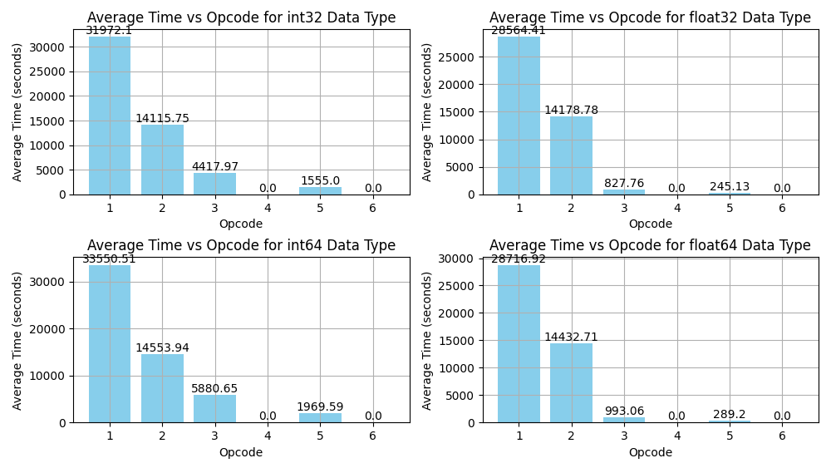
Number of threads being used: 4

Reason: matrix multiplication on 1024x1024 matrix was done to test speedup on 16, 8, 4, 2, 1 threads. 16 and 8 showed no improvement and only added to the multithreading overhead. 4 was the most optimal as 2 and 1 showed worse times.

Part 5

(a) What did you learn in this assignment? Did you have some interesting insights?
Ans:
- One of the most interesting insight was how big of an impact choice of programming language is.
- Another interesting insight was Java did disk read and writes while python and C did not (According to System Monitor).
- Java and Python donot have overflow and underflow errors while C does.
- Multiplication of 2 int32 can sometimes take more space than 64 bit and have to be stored in 128 bit integer (long long int). But adding 4096 of these results together sometimes took even 256bits to store thats why gmp library was used to get the help of mpz_t variable.
- Eventhough the target device had upto 8 threads but it only gave speedup for upto 4 threads. That is the same number of cores in the target device
(b) Which single way gave you the maximum speed up in relative terms? Programming
language change, vector instructions or multithreading?
Ans:
- Programming language gave the maximum speed up in relative terms. Although if there was a more powerful device that might not be the case. But C is very fast as compared to Java and Python

(c) The Karp-Flatt metric looks at serial part+overhead while we change the number of
processors, though if we extend the definition of “processor” we might be able to use
that metric. Assuming that any speed up from language change to vectors to
multithreading to (vector+multithreading) is due to increasing processor count, what do
your metric numbers suggest about the quality of your speed up and is it plateauing?
Ans:
- Considering change of language as increasing processor count. The quality of speed up was maximum. E.g Just going from Python to C it had a 7.2 speedup for dataType1. However, the speedup from multithreading was not very promising as in dataType 1 it only gave 2.8 speedup when there were 4 times more cores used than before, showing the effects of parrallel overhead.

Speedups

 | int32 | float | int64 | double
Python→ C | 7.2 | 34.5 | 5.7 | 28.9
1→4 cores | 2.8 | 3.37 | 2.98 | 3.43

- Another interesting thing that can be seen is how int32 and int64 have such low results as compared to float and double. That is because a seperate gmp library was used to get access of 256bit mpz_t variable which itself had an overhead.

Conclusion

Parallelization although does provide speedup but the quality of it plateaus soon enough. The real benefits were seen when there were change in programming language and other small aspects such as the size of variables that made the biggest impact. However, changes like these often seem as boring but have the biggest impact when talking about large scale computation. One takeaway from the findings that can be taken is not only the code needs to be parallelized but the serial part of the code needs to be optimized as well. If performance is something valued greater than abstraction. Programmers coding in python and Java do need to consider their choice of language they are coding in.

